**CRI-CIMT-EATI-AACR INTERNATIONAL CANCER IMMUNOTHERAPY CONFERENCE**

**Header and Side tab:** Second CRI-CIMT-EATI-AACR International Cancer Immunotherapy Conference: Translating Science into Survival

**Date:** September 25-28, 2016

**Venue:** Sheraton New York Times Square Hotel New York, New York

**Description:** The Cancer Research Institute (CRI), the Association for Cancer Immunotherapy (CIMT), the European Academy of Tumor Immunology (EATI), and the American Association for Cancer Research (AACR) are proud to once again join forces to present the International Cancer Immunotherapy Conference. The program will focus on “Translating Science into Survival” and feature talks from more than 60 leaders in the field covering all areas of inquiry in cancer immunology and immunotherapy. This meeting will provide an unparalleled opportunity for teaching, learning, and networking among all stakeholders in the field: scientists, clinicians, regulators, drug developers, and patient advocates.

**Image:**

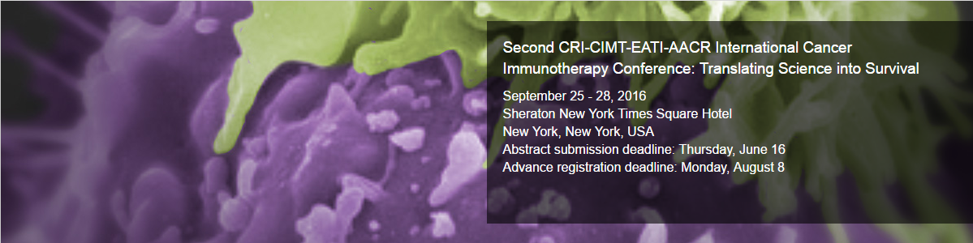

**To know more link:** http://www.aacr.org/Meetings/Pages/MeetingDetail.aspx?EventItemID=101#.V8L0Gk197IU

**AACR Tumor Immunology & Immunotherapy**

**Header and Side tab:** Tumor Immunology and Immunotherapy

**Date:** October 20 - 23, 2016

**Venue:** Boston Marriott Copley Place, Boston, Massachusetts, USA

**Description:** A hallmark of this AACR immunology series is the integration of several sub-disciplines of cancer immunology and immunotherapy, with a broad focus on strategies to harness the immune system for the treatment and prevention of different cancers. Leaders in the field will present their latest work and provide critical updates on our deepening understanding of the immune response towards cancer. This Special Conference will also provide a unique opportunity for the authors of highly rated abstracts to present their work to an audience of researchers from around the world. Ample time will be provided for the stimulating discussions that are necessary to further the scientific and translational goals of the field. As the sixth in the series, this conference will continue to provide a forum for the effective exchange of ideas between basic cancer immunologists, non-immunologists and clinical oncologists, from academia to industry.

**Image:**

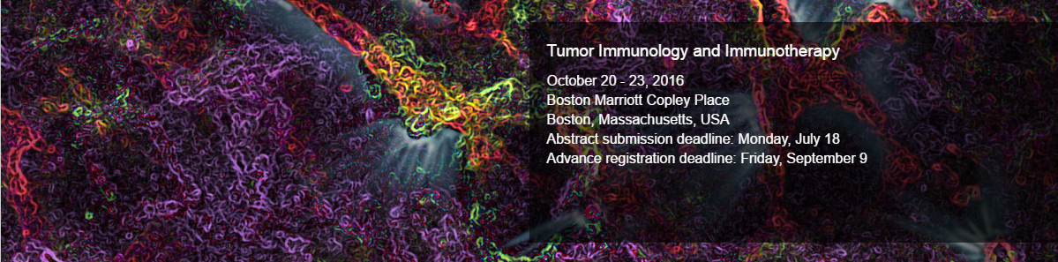

**To know more link:**

http://www.aacr.org/Meetings/Pages/MeetingDetail.aspx?EventItemID=92#.V8L2Nk197IU

**31st Annual Meeting & Associated Programs, SITC**

**Header and Side tab:** 31st Annual Meeting & Associated Programs, SITC

**Date:** November 9-13, 2016

**Venue:** Gaylord National Hotel & Convention Center in National Harbor, Maryland

**Description:** Known as the premier destination for scientific exchange, education and networking in the cancer immunotherapy field, this is the conference you don't want to miss! With more than 2,400 people from across the globe attending SITC 2015, we look forward to continuing the discussion surrounding the newest science, insights and innovation in the cancer immunotherapy community at SITC 2016!

**Image:**



**To know more link:**

**http://www.sitcancer.org/2016**

**Neoantigen Summit 2016**

**Header and Side tab:** Neoantigen Summit 2016

**Date:** November 15-17th 2016

**Venue:** Boston, MA

**Description:** The Neoantigen Summit 2016 is perfectly timed to help guarantee the successful translation of exponentially more effective and commercially viable personalized immunotherapies to market, particularly for solid tumor indications.

As the field enthusiastically seeks to demonstrate significantly improved therapeutic efficacy, especially for solid tumors, join the collaborative ecosystem at the Neoantigen Summit to make the scientific, clinical and commercial refinements you need for therapeutic success.

**Image:**

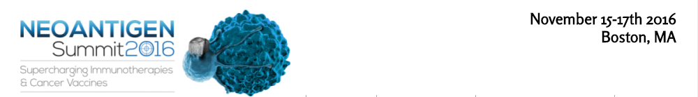

**To know more link:**

http://neo-antigen.com/